Relativity Dev VM

Running Chef Script

Documentation

[April 3, 2018]

Table of Contents

1 Requirements 3

2 Downloads 3

2.1.1 Relativity installation 4

2.1.2 SQL Server 2016 Developer Edition 4

2.1.3 Service Bus 1.1 Defect Windows Update 4

2.1.4 Install Visual Studio Code text editor 5

3 Setup Workstation 5

3.1 Login 5

3.2 Setup PowerShell 5

3.3 Install Chocolatey 7

3.4 Install GIT Version 2.14.1 7

3.5 Clone Dev VM repository from Github 8

3.6 Install Chef Development Kit Version 2.4.17 8

3.7 Enable the Hyper-V Windows feature 9

3.8 Setup Hyper-V Virtual Switch 12

3.9 Share Internet Connection 15

3.10 Install Vagrant Version 2.0.1 17

3.11 Install Vagrant Reboot plugin 17

3.12 Install Vagrant berkshelf plugin 18

3.13 Add Dev VM Windows Base machine to Vagrant boxes list 18

4 Create New Dev VM 19

4.1 Login 19

4.2 Navigate to the Dev VM GIT repository 19

4.3 Switch to vagrant-poc branch 19

4.4 Copy the config.yaml file required for Dev VM 19

4.5 Update Configuration file 22

4.6 Run the Dev VM Creation script 22

4.6.1 Navigate to the Dev VM GIT repository 22

4.6.2 List all the files in Chef folder 23

4.6.3 Run the Creation script 23

5 Clean Workstation 24

5.1 Login 24

5.2 Remove Vagrant Box Image 24

5.3 Uninstall Vagrant berkshelf plugin 24

5.4 Uninstall Vagrant reload plugin 24

5.5 Uninstall Vagrant 24

5.6 Uninstall Chocolatey 24

5.7 Remove Hyper-V Virtual Switch 25

5.8 Uninstall Hyper-V 25

5.9 Uninstall Chef Development Kit 25

# Requirements

* CPU cores: 4 cores
* RAM: 12GB
* Storage: 140GB
* Licenses
  + Windows Server 2012 R2
  + Relativity
* Windows 10 Pro with Hyper-V features enabled.
* Windows Admin account.
* Internet connection

# Downloads

* List of files needed for running the Vagrant/Chef recipes.
  + Relativity installer
  + Invariant installer
  + Secret Store
  + Datagrid
  + SQL Server 2016 Developer Edition
  + Service Bus Defect Windows update
  + Visual Studio Code text editor
  + MS Office Professional Plus 2010
  + MS Works Converter
  + Lotus Notes
  + Jungum

### Relativity installation

* Please contact [support@relativity.com](mailto:support@relativity.com) to get the installer files for the following:
  + Relativity
  + Invariant
  + Secret Store
  + Datagrid

### SQL Server 2016 Developer Edition

* You can download it at this link - <https://www.microsoft.com/en-us/sql-server/application-development>

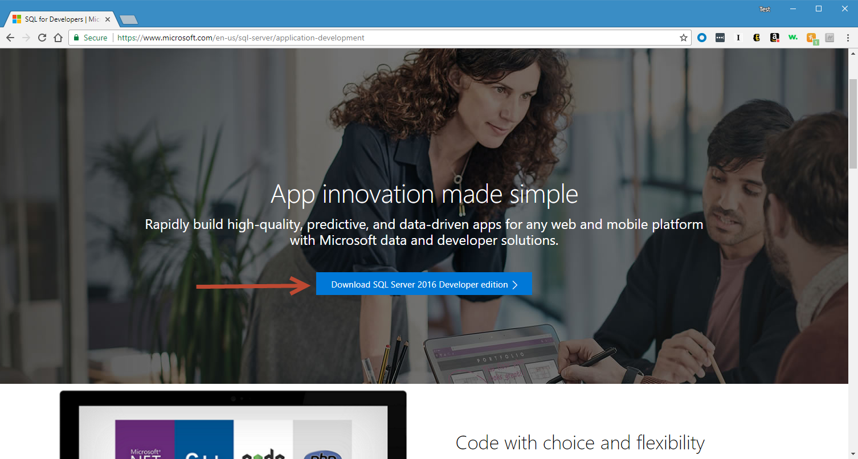

### Service Bus 1.1 Defect Windows Update

* You can download it at this link - <https://www.microsoft.com/en-us/download/details.aspx?id=49496>

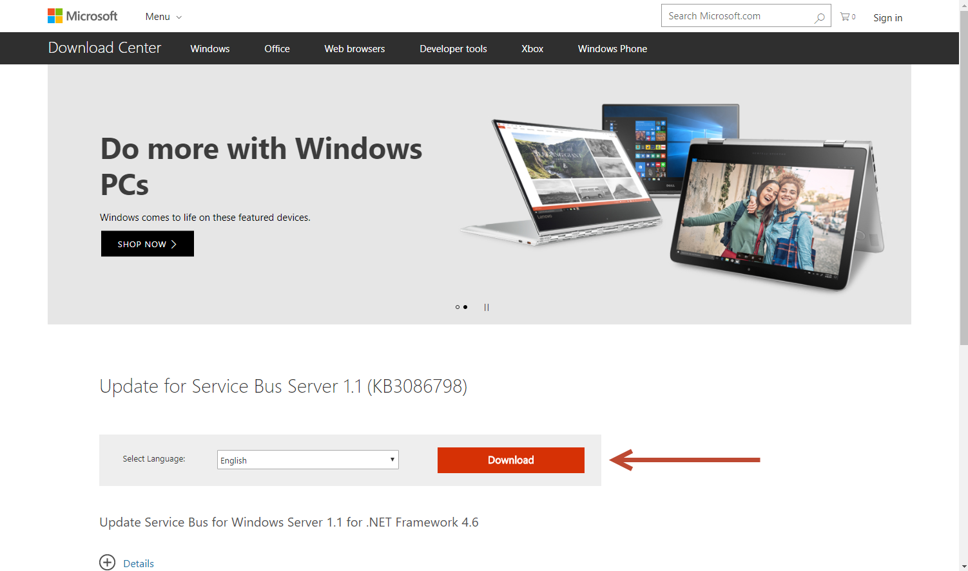

### Install Visual Studio Code text editor

* Download and Install Visual Studio Code from this link [Visual Studio Code](https://code.visualstudio.com/)

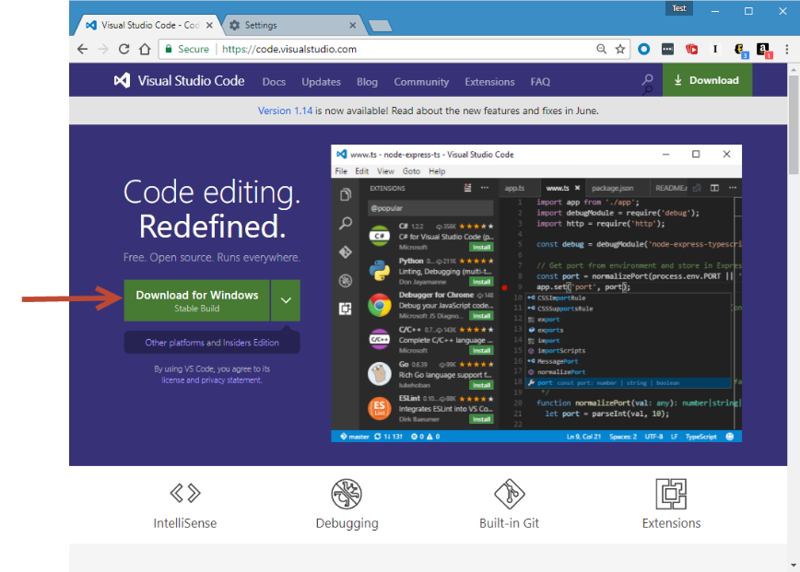

# Setup Workstation

* It’s important that you run the below steps in order.

## Login

* Login into your workstation with a Windows Administrator account.

## Setup PowerShell

* Let’s configure PowerShell to always open as an Administrator.
* Pin **PowerShell** to your Task Bar
* Right click on **Windows PowerShell** then **Properties**

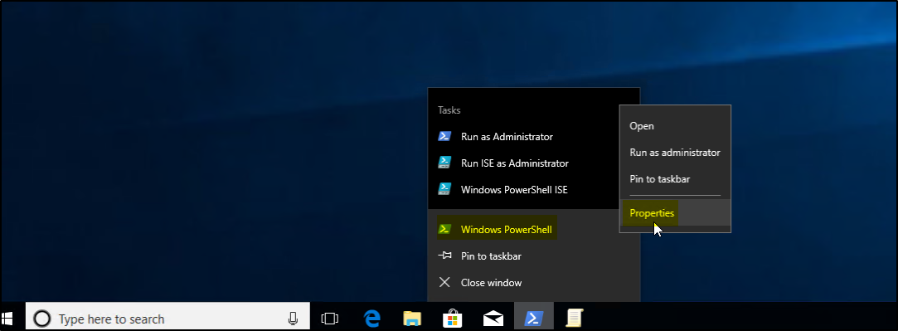

* Find the tab called **Shortcut**, then **Advanced**, then **Run As Administrator**

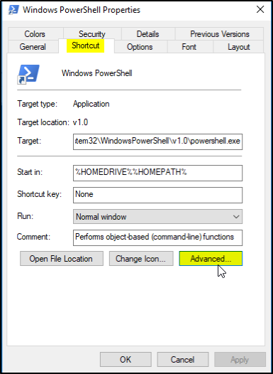

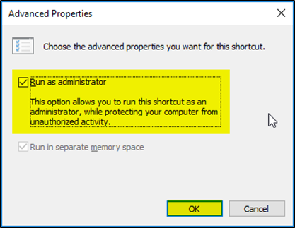

* Open a PowerShell window (should be opening as an Administrator now) and run the following command:

Set-ExecutionPolicy Unrestricted

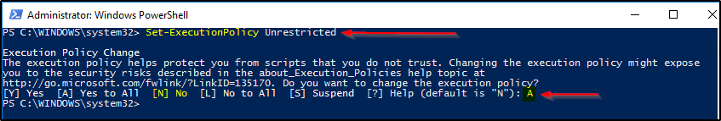

## Install Chocolatey

* Run the following command in PowerShell window.

Set-ExecutionPolicy Bypass -Scope Process -Force; iex ((New-Object System.Net.WebClient).DownloadString('https://chocolatey.org/install.ps1'))

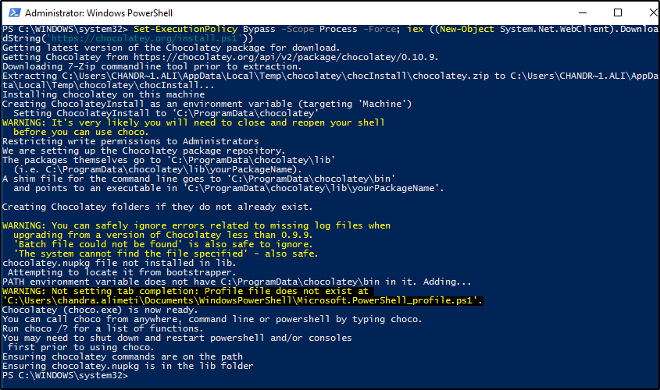

## Install GIT Version 2.14.1

* Run the following command in PowerShell window.

choco install git --version 2.14.1

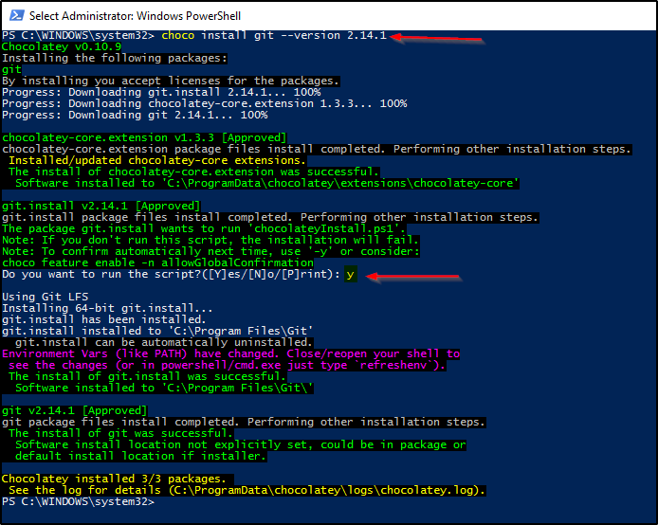

## Clone Dev VM repository from Github

* Run the follo
* wing command in PowerShell window.

cd "C:\"

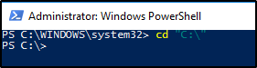

* Run the following command in PowerShell window.

git clone https://github.com/relativitydev/relativity-dev-vm.git

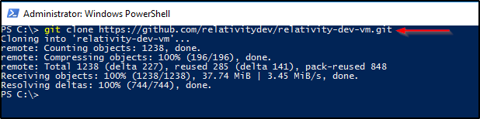

## Install Chef Development Kit Version 2.4.17

* Run the following command in PowerShell window.

. { iwr -useb https://omnitruck.chef.io/install.ps1 } | iex; install -project chefdk -channel stable -version 2.4.17

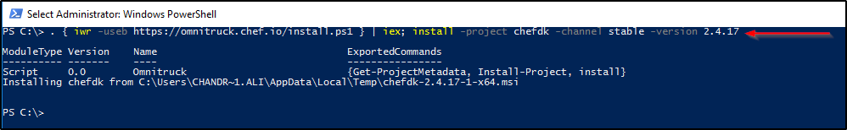

## Enable the Hyper-V Windows feature

* Run the following command in PowerShell window.

Enable-WindowsOptionalFeature -Online -FeatureName Microsoft-Hyper-V -All -NoRestart

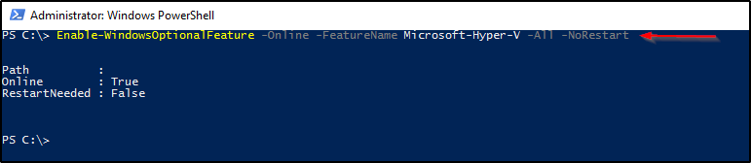

* **Restart your workstation.**
* Verify Windows Hyper-V feature installation
  + Once your workstation finished restart, Go to **Programs and Features**

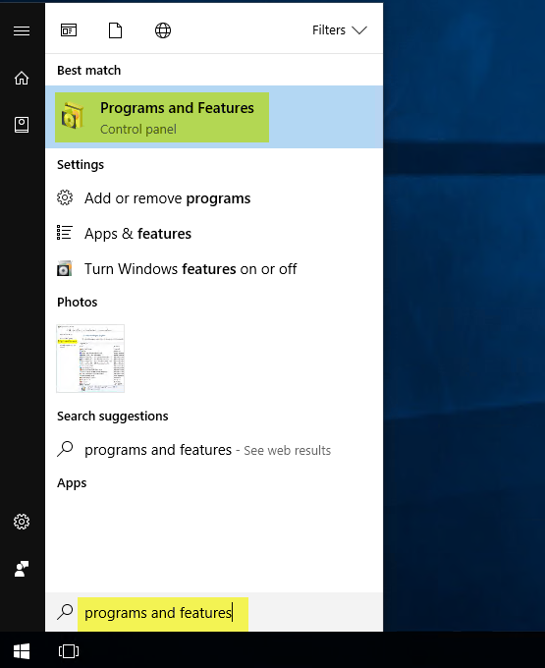

* + Click on **Turn Windows features on or off**

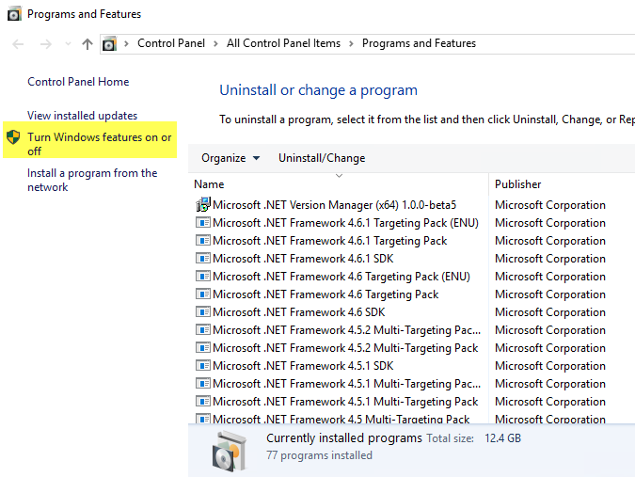

* + Verify if Hyper-V is checked as shown in the below screenshot

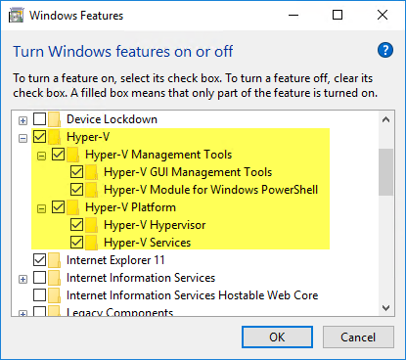

* + You can also verify Hyper-V installation via PowerShell
    - Run the following command in PowerShell window. You should see results as shown in the below screenshot.

Get-Command –Module Hyper-V

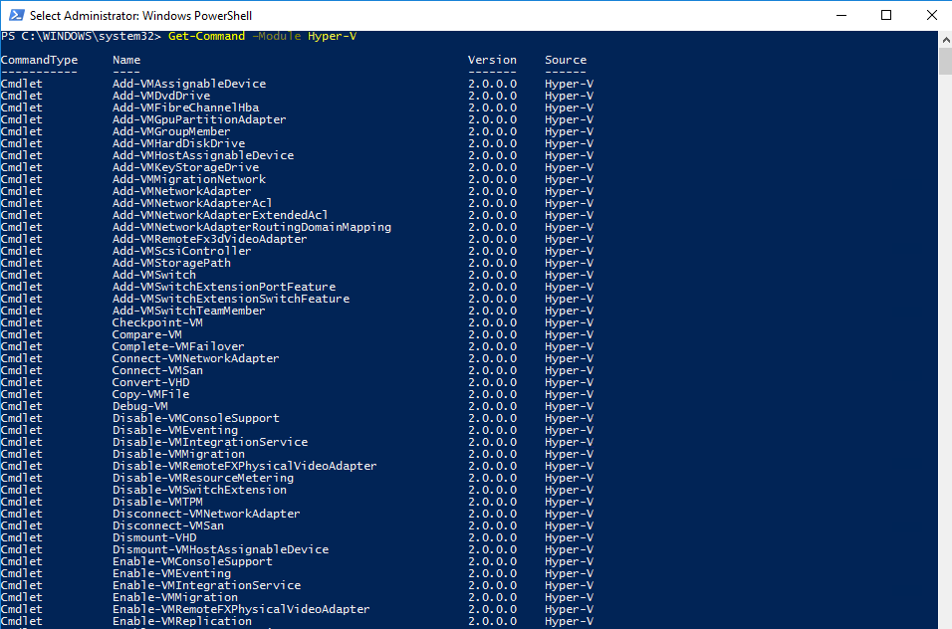

## Setup Hyper-V Virtual Switch

* Open the **Hyper-V Manager** application.

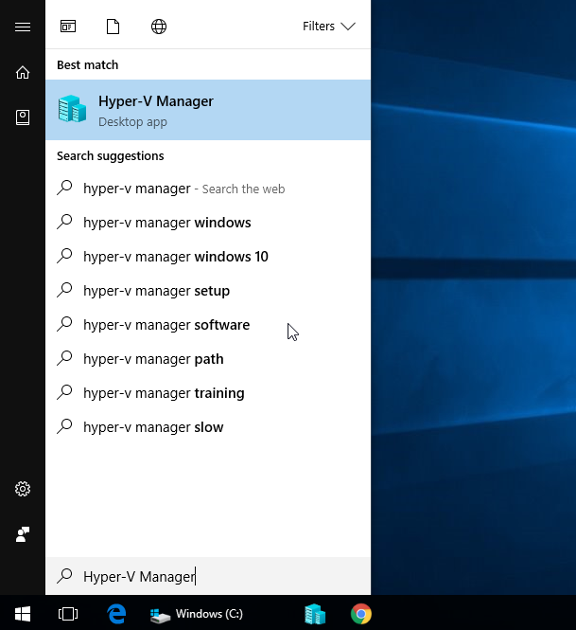

* Make sure you have an **External Virtual Switch** which lets you access your VM from your local machine.
  + Select your local machine from the left pane.
  + In the Actions pane located in **Hyper-V Manager**, click on the **Virtual Switch Manager** link, see screenshot below.

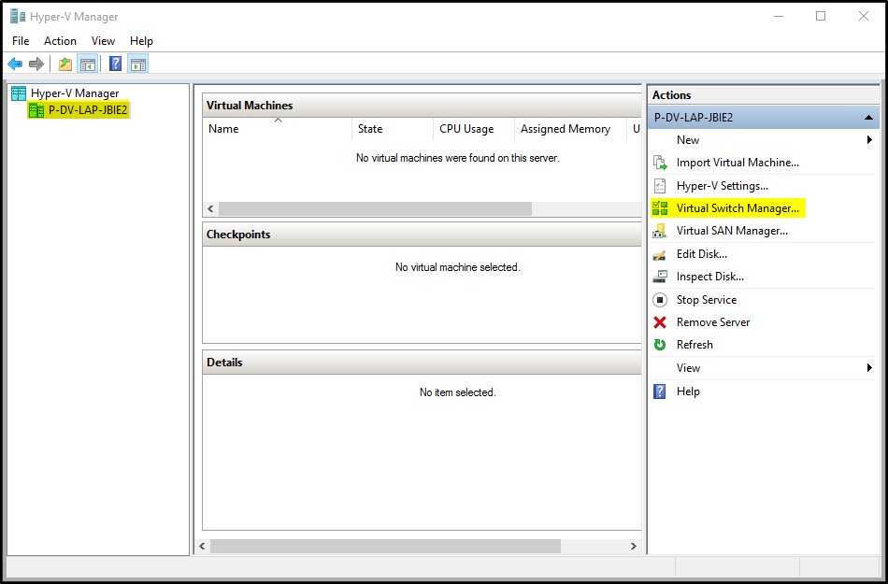

* + If you don’t already have an external network switch please click the **New virtual network switch** link under **Virtual Switches**. Select **External** for the type of switch and click on the **Create Virtual Switch** button.

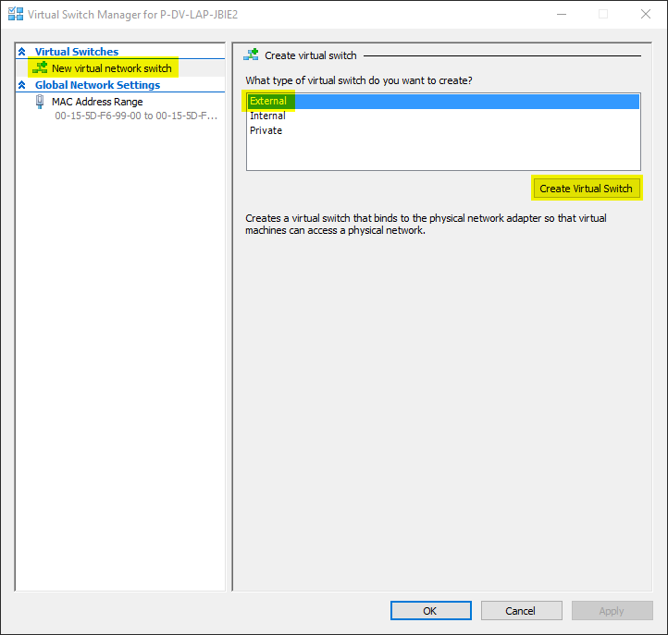

* + Provide a friendly name for the new switch (For example: **RelativityDevVmSwitch**) and click **Apply** button.

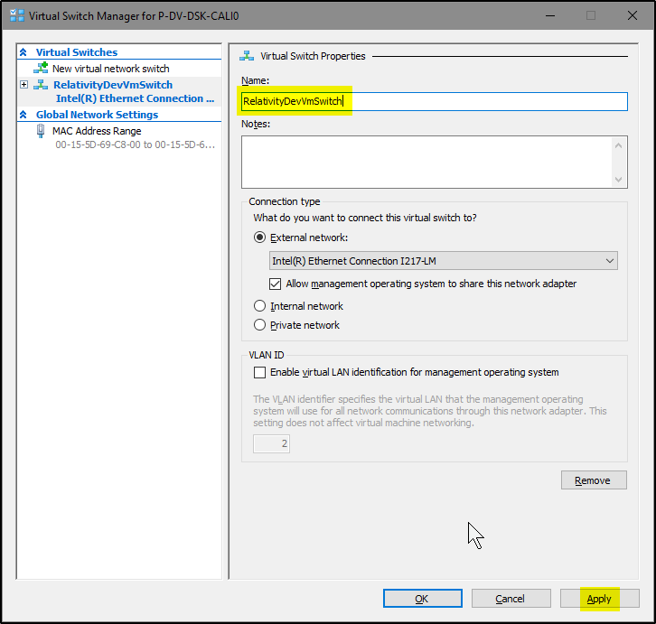

* + If you get a warning message (see screenshot below), please click the **Yes** button.

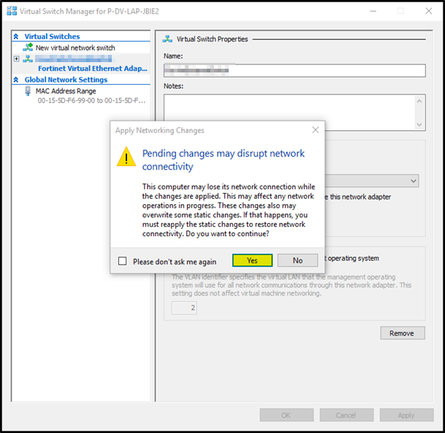

* + Next click the **OK** button to create your new virtual switch.

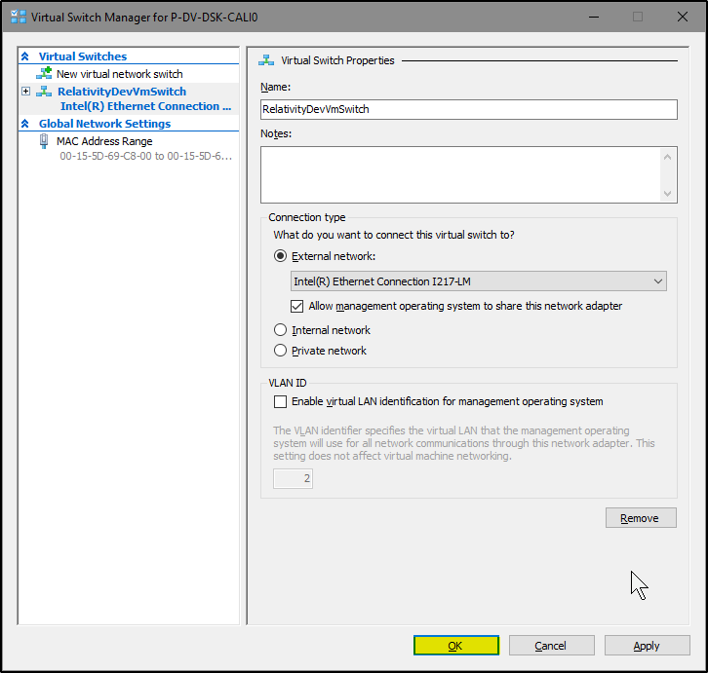

## Share Internet Connection

* Sharing the internet connection of your workstation with the Dev VM will make it easy to access it.
* Open **Network and Sharing Center** application on your workstation.

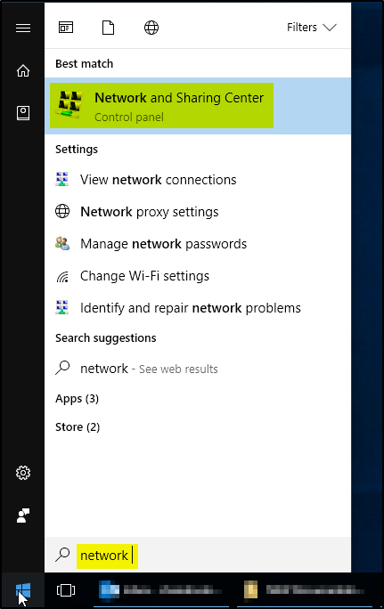

* Click on **Change adapter settings** link on the left pane.

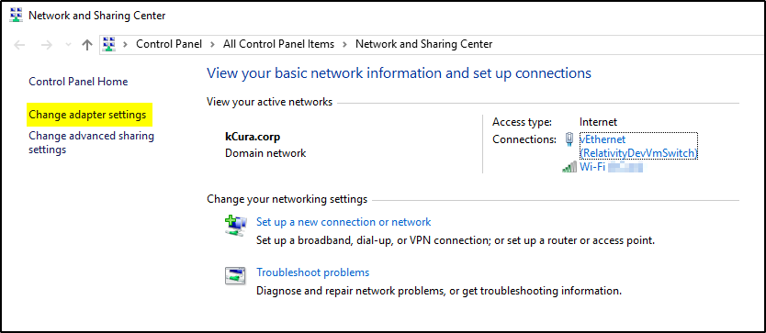

* Right click on the Network connection which has the internet access and select **Properties**.

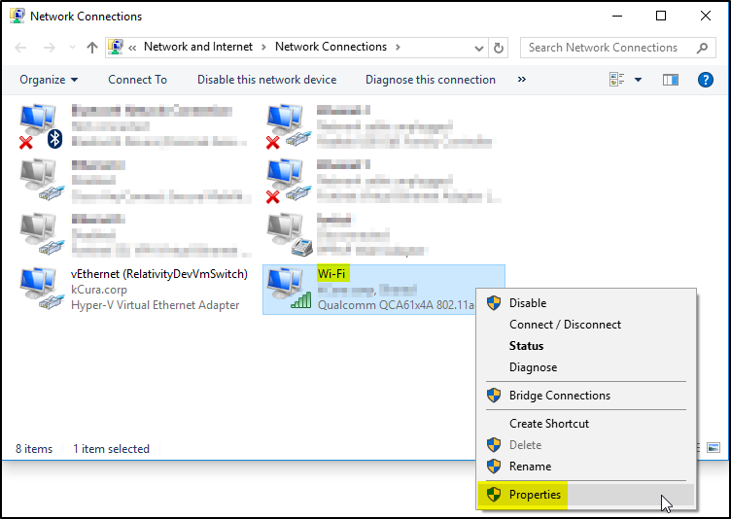

* Select **Sharing** tab, select the checkbox for **Allow other network users to connect through this computer’s Internet connection** option. From the dropdown, select the virtual switch you created for Dev VM and click OK.

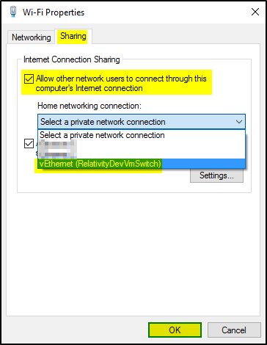

## Install Vagrant Version 2.0.1

* Run the following command in PowerShell window.

choco install vagrant --version 2.0.1

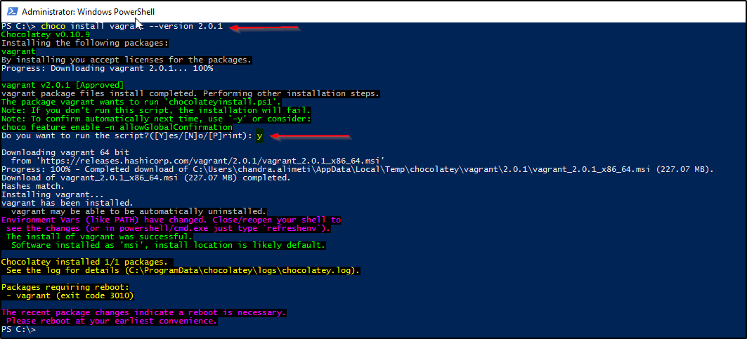

* **Restart your workstation.**

## Install Vagrant Reboot plugin

* Run the following command in PowerShell window.

vagrant plugin install vagrant-reload

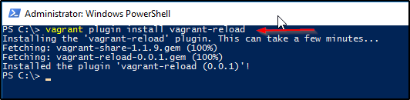

* If you see a popup, select **Allow access** as shown in below screenshot.t

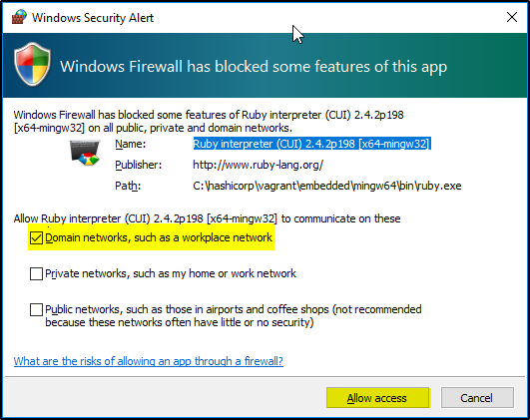

## Install Vagrant berkshelf plugin

* Run the following command in PowerShell window.

vagrant plugin install vagrant-berkshelf

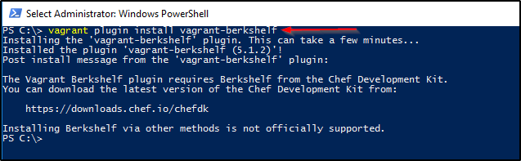

## Add Dev VM Windows Base machine to Vagrant boxes list

* Follow the instructions provided in a different document to create a Windows Base machine. This Windows Base image is needed to run the Vagrant/Chef scripts.
* Once you have the Windows Base box image ready, copy it to your C drive.

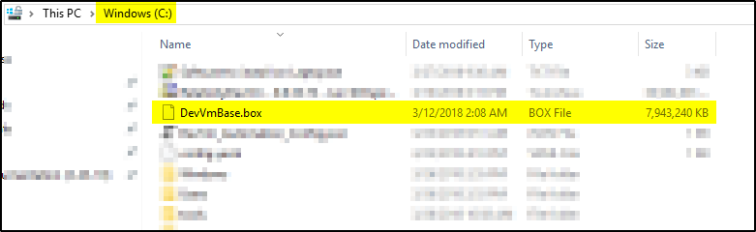

* Next we need to add the Windows Base box image to the Vagrant boxes list. Run the following command in PowerShell window.

vagrant box add "DevVmBaseImage" C:\DevVmBase.box

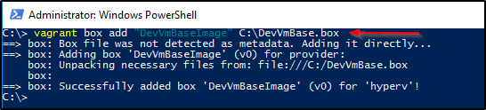

* Confirm the vagrant box was successfully added. Run the following command in PowerShell window.

vagrant box list

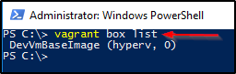

# Create New Dev VM

* It’s important that you run the below steps in order.

## Login

* Login into your workstation with a Windows Administrator account.

## Navigate to the Dev VM GIT repository

* Run the following command in PowerShell window.

cd "C:\relativity-dev-vm\"

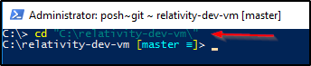

## Switch to vagrant-poc branch

* Run the following command in PowerShell window.

git checkout vagrant-poc

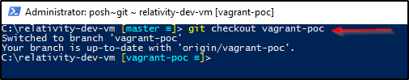

## Copy the config.yaml file required for Dev VM

* Run the following command in PowerShell window.

start .

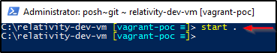

* This opens the current folder in Windows Explorer.

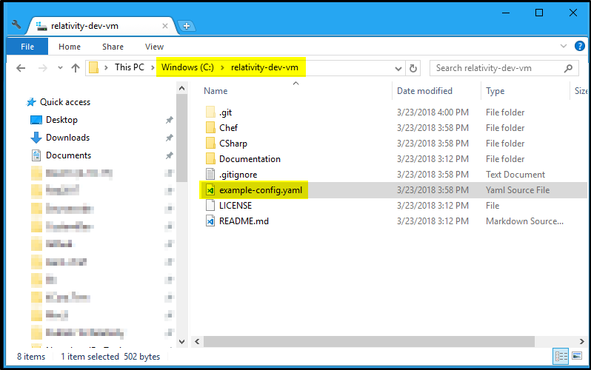

* Copy the **example-config.yaml** file from **C:\relativity-dev-vm** folder to **C drive** and rename it to **config.yaml**.

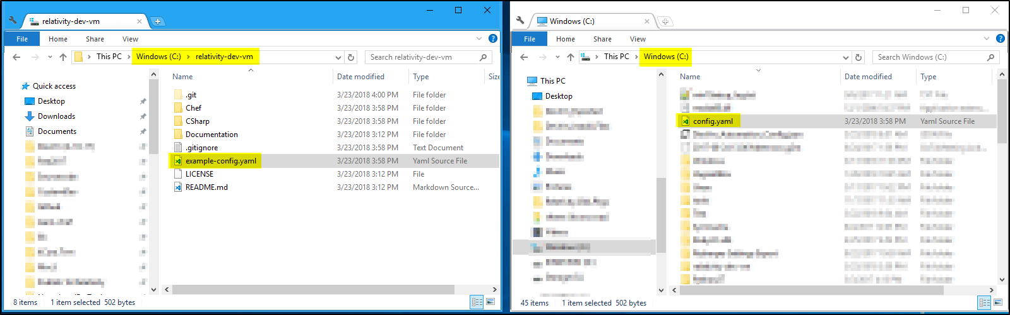

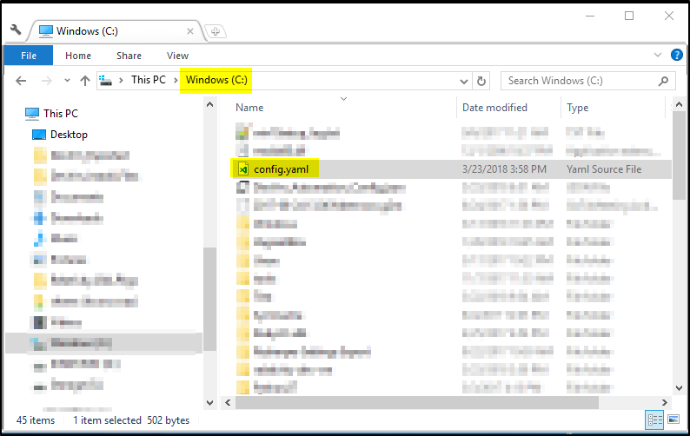

* Open the **config.yaml** file from **C drive** in Notepad.

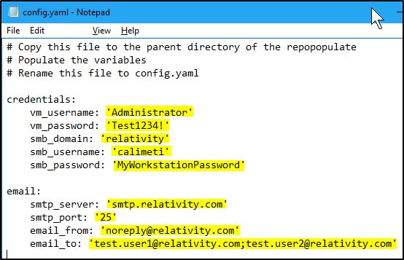

* Update the properties in the **config.yaml** file. Please find below a brief description of each property.
  + **vm_username**: Windows Admin username of the Dev VM.
  + **vm_password**: Windows Admin password of the Dev VM.
  + **smb_domain**: Domain of your workstation. If your workstation is not part of a domain, use your workstation computer name.
  + **smb_username**: Windows Admin username of your workstation.
  + **smb_password**: Windows Admin password of your workstation.
  + **smtp_server**, **smtp_port**, **email_from**, **email_to** will be values for the email server on your domain. These values will be used to send the report of the Smoke tests run after the Dev VM creation.
* Save the changes to the **config.yaml** file.

## Update Configuration file

* Navigate to the configuration file directory. Run the following command in PowerShell window.

cd "C:\relativity-dev-vm\Chef\Cookbooks\Relativity\attributes"

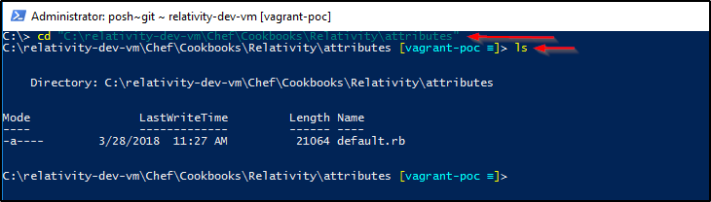

* The directory contains one file name **default.rb**.
* Open the **default.rb** file and update the necessary properties.

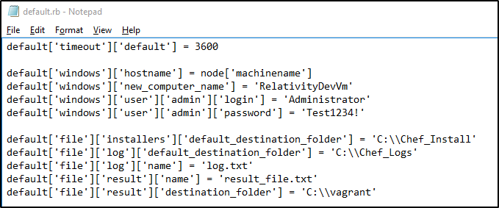

## Run the Dev VM Creation script

### Navigate to the Dev VM GIT repository

* Run the following command in PowerShell window.

cd "C:\relativity-dev-vm\Chef\"

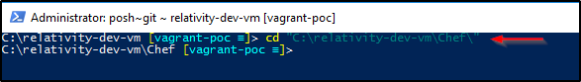

### List all the files in Chef folder

* Run the following command in PowerShell window.

ls

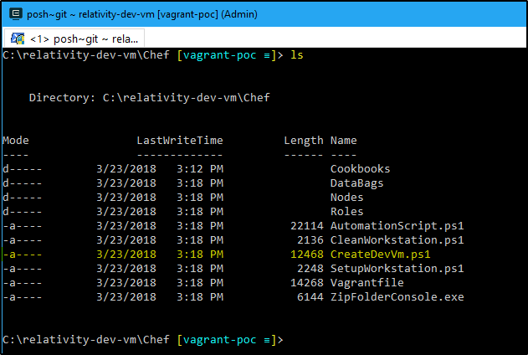

* **CreateDevVm.ps1** PowerShell script has the code to create a new Dev VM.

### Run the Creation script

* Run the following command in PowerShell window.

.\CreateDevVm.ps1

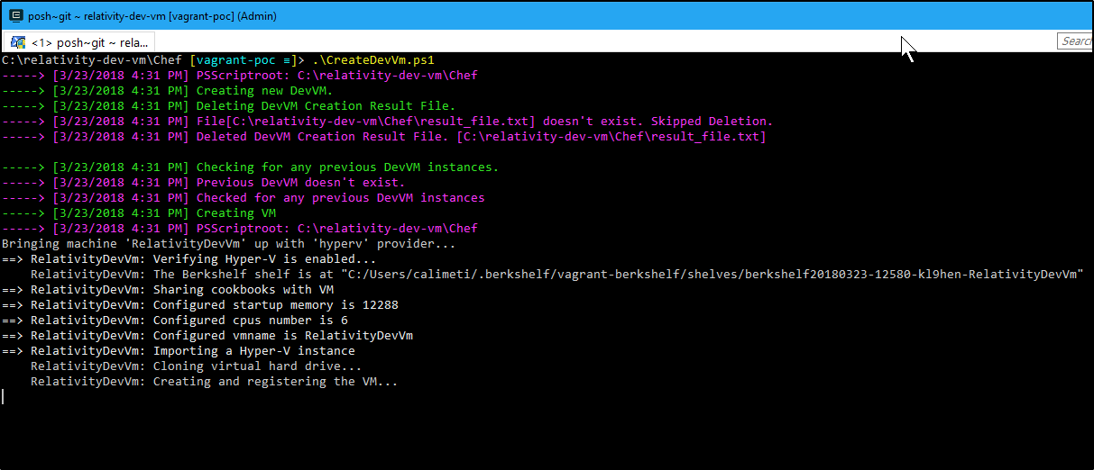

* Once the script finishes execution successfully, you should be able to see a

# Clean Workstation

* It’s important that you run the below steps in order.

## Login

* Login into your workstation with a Windows Administrator account.

## Remove Vagrant Box Image

* Run the following command in PowerShell window.

vagrant box remove "DevVmBaseImage" –force

## Uninstall Vagrant berkshelf plugin

* Run the following command in PowerShell window.

vagrant plugin uninstall vagrant-berkshelf

## Uninstall Vagrant reload plugin

* Run the following command in PowerShell window.

vagrant plugin uninstall vagrant-reload

## Uninstall Vagrant

* Run the following command in PowerShell window.

choco uninstall vagrant –force

## Uninstall Chocolatey

* Run the following command in PowerShell window.

Remove-Item -Recurse -Force "$env:ChocolateyInstall"

* Run the following command in PowerShell window.

[System.Text.RegularExpressions.Regex]::Replace([Microsoft.Win32.Registry]::CurrentUser.OpenSubKey('Environment').GetValue('PATH', '', [Microsoft.Win32.RegistryValueOptions]::DoNotExpandEnvironmentNames).ToString(), [System.Text.RegularExpressions.Regex]::Escape("$env:ChocolateyInstall\bin") + '(?>;)?', '', [System.Text.RegularExpressions.RegexOptions]::IgnoreCase) | % {[System.Environment]::SetEnvironmentVariable('PATH', $_, 'User')}

* Run the following command in PowerShell window.

[System.Text.RegularExpressions.Regex]::Replace([Microsoft.Win32.Registry]::LocalMachine.OpenSubKey('SYSTEM\CurrentControlSet\Control\Session Manager\Environment\').GetValue('PATH', '', [Microsoft.Win32.RegistryValueOptions]::DoNotExpandEnvironmentNames).ToString(), [System.Text.RegularExpressions.Regex]::Escape("$env:ChocolateyInstall\bin") + '(?>;)?', '', [System.Text.RegularExpressions.RegexOptions]::IgnoreCase) | % {[System.Environment]::SetEnvironmentVariable('PATH', $_, 'Machine')}

* Run the following command in PowerShell window.

if ($env:ChocolateyBinRoot -ne '' -and $env:ChocolateyBinRoot -ne $null) { Remove-Item -Recurse -Force "$env:ChocolateyBinRoot" }

* Run the following command in PowerShell window.

if ($env:ChocolateyToolsRoot -ne '' -and $env:ChocolateyToolsRoot -ne $null) { Remove-Item -Recurse -Force "$env:ChocolateyToolsRoot" }

* Run the following command in PowerShell window.

[System.Environment]::SetEnvironmentVariable("ChocolateyBinRoot", $null, 'User')

* Run the following command in PowerShell window.

[System.Environment]::SetEnvironmentVariable("ChocolateyToolsLocation", $null, 'User')

## Remove Hyper-V Virtual Switch

* Run the following command in PowerShell window.

Remove-VMSwitch "RelativityDevVmSwitch" -Force

## Uninstall Hyper-V

* Run the following command in PowerShell window.

Disable-WindowsOptionalFeature -Online -FeatureName Microsoft-Hyper-V -NoRestart

* **Restart your workstation.**

## Uninstall Chef Development Kit

* Open **Programs and Features** application.
* Search for **Chef Development Kit**, select it and click Uninstall.

